**Power BI Assignment 3**

1. List and explain different PowerBi products?

Answer: **Power BI Desktop**: Power BI Desktop is a free Windows application that allows users to create rich and interactive reports and visualizations. It provides advanced data modeling, transformation, and visualization capabilities and is used for authoring reports before publishing them to the Power BI Service.

* **Power BI Service (Power BI Pro and Power BI Premium)**: The Power BI Service is a cloud-based platform for sharing, collaborating on, and consuming Power BI reports and dashboards. It offers different licensing options:
  + **Power BI Pro**: A subscription-based model that allows individuals to create, publish, and share reports with other Power BI Pro users. It supports collaboration, automatic data refresh, and more.
  + **Power BI Premium**: A capacity-based licensing model that provides dedicated resources for better performance, larger datasets, and additional features. It also supports on-premises reporting using Power BI Report Server.
* **Power BI Mobile Apps**: Power BI Mobile Apps are available for iOS and Android devices. These apps enable users to access, interact with, and share Power BI reports and dashboards on the go. Reports are optimized for mobile viewing.
* **Power BI Report Server**: Power BI Report Server is an on-premises solution that allows organizations to publish and manage Power BI reports within their own infrastructure. It's useful for scenarios where data must remain within an organization's network.
* **Power BI Embedded**: Power BI Embedded is designed for developers to embed Power BI reports and dashboards into custom applications, websites, or portals. It provides a way to integrate Power BI capabilities seamlessly within other applications.
* **Power BI Dataflows**: Power BI Dataflows is a cloud-based service that enables users to discover, connect, transform, and load data from various sources into a centralized data store. This data can then be used across reports and dashboards.
* **Power BI Premium Per User (PPU)**: Power BI Premium Per User is a licensing option that provides some of the benefits of traditional Power BI Premium to individual users. It offers features like paginated reports, AI capabilities, and larger dataset capacity.
* **Power BI Goals**: Power BI Goals is a feature that enables organizations to set, track, and visualize key performance indicators (KPIs) and metrics, allowing for performance monitoring and goal achievement tracking.
* **Power BI Insights Apps**: Power BI Insights Apps are pre-built industry-specific or business function-specific templates that provide a curated set of reports, dashboards, and datasets to accelerate insights for specific domains.

1. What limitations of Excel, Microsoft solved by PowerBi?

Answer:

Power BI was developed by Microsoft to address several limitations of Excel, particularly when it comes to handling and analyzing large and complex datasets, as well as providing a more collaborative and dynamic approach to data visualization and analysis. Here are some limitations of Excel that Power BI aims to solve:

* **Handling Large Datasets**: Excel can struggle with handling very large datasets, leading to performance issues and slower calculations. Power BI's in-memory data model and compression techniques enable it to handle larger datasets more efficiently.
* **Complex Data Transformations**: Excel's data transformation capabilities are limited compared to Power BI's Power Query, which provides a more robust and user-friendly environment for cleansing, shaping, and transforming data.
* **Data Model Flexibility**: Power BI offers more advanced data modeling capabilities with the ability to define relationships, hierarchies, and calculated columns in a more structured manner compared to Excel.
* **Interactive Dashboards**: While Excel can create charts and graphs, Power BI focuses on creating interactive and visually compelling dashboards that allow users to explore data dynamically.
* **Real-Time Data Updates**: Power BI can connect to live data sources and offer real-time data refresh, whereas Excel often requires manual updating or refreshes.
* Version Control and Collaboration: Excel files can become complex and unwieldy, making it challenging to manage version control and collaborate effectively. Power BI Service allows users to collaborate on reports and dashboards, making updates and sharing easier.
* **Data Exploration**: Power BI provides a more intuitive way to explore data using visualizations and natural language queries, whereas Excel's data exploration can be more limited and formula-based.
* **Limited Mobility**: Power BI's mobile apps allow users to access and interact with reports and dashboards on mobile devices more effectively than Excel, which might not be optimized for mobile viewing.
* **Performance and Responsiveness**: Power BI's optimized data engine ensures faster performance and responsiveness, especially when dealing with complex calculations and interactions in reports.
* **Data Source Connectivity**: Power BI offers a broader range of data connectors and integrations, making it easier to connect to various data sources, including cloud-based services.
* Scalability: Power BI's scalability is better suited for handling enterprise-level analytics and reporting needs, whereas Excel might struggle to scale efficiently.
* **Embedded Analytics**: Power BI Embedded allows developers to embed interactive reports and dashboards within custom applications, which isn't as seamlessly achievable with Excel.
* Automated Reporting: Power BI's automated data refresh and scheduled report generation are more streamlined than Excel's manual refresh and reporting processes.

While Excel remains a versatile tool for general data analysis, Power BI was designed to address the limitations associated with handling larger and more complex datasets, promoting collaborative data analysis, and providing a more dynamic and interactive reporting environment for business intelligence needs.

1. Explain PowerQuery.

Answer:

Power Query is a data transformation and data preparation engine. Power Query comes with a graphical interface for getting data from sources and a Power Query Editor for applying transformations. Because the engine is available in many products and services, the destination where the data will be stored depends on where Power Query was used. Using Power Query, you can perform the extract, transform, and load (ETL) processing of data.

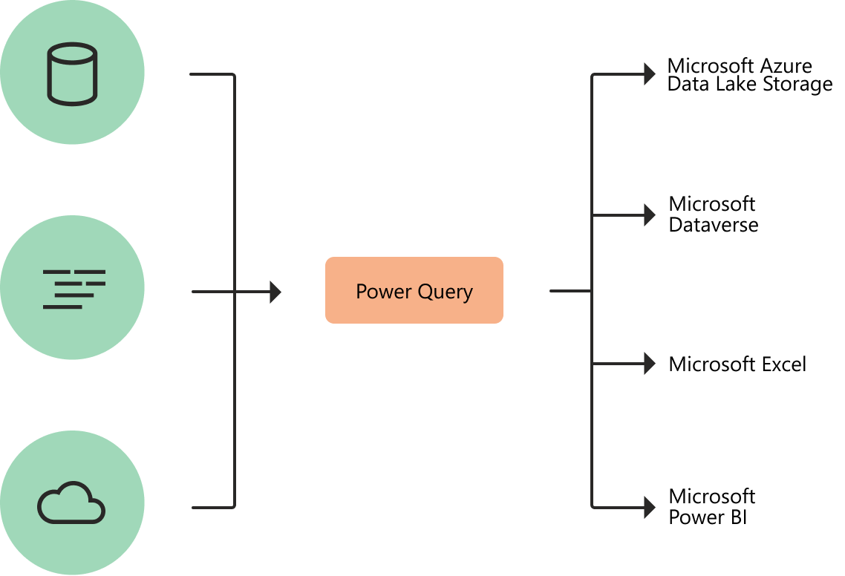

Diagram with symbolized data sources on the left, passing through Power Query for transformation in the center, and then going to four destinations on the right: Microsoft Azure Data Lake Storage, Microsoft Dataverse, Microsoft Excel and Microsoft Power BI.

## **How Power Query helps with data acquisition**

Business users spend up to 80 percent of their time on data preparation, which delays the work of analysis and decision-making. Several challenges contribute to this situation, and Power Query helps address many of them.

| **Existing challenge** | **How does Power Query help?** |
| --- | --- |
| Finding and connecting to data is too difficult | Power Query enables connectivity to a wide range of data sources, including data of all sizes and shapes. |
| Experiences for data connectivity are too fragmented | Consistency of experience, and parity of query capabilities over all data sources. |
| Data often needs to be reshaped before consumption | Highly interactive and intuitive experience for rapidly and iteratively building queries over any data source, of any size. |
| Any shaping is one-off and not repeatable | When using Power Query to access and transform data, you define a repeatable process (query) that can be easily refreshed in the future to get up-to-date data.  In the event that you need to modify the process or query to account for underlying data or schema changes, you can use the same interactive and intuitive experience you used when you initially defined the query. |
| Volume (data sizes), velocity (rate of change), and variety (breadth of data sources and data shapes) | Power Query offers the ability to work against a subset of the entire dataset to define the required data transformations, allowing you to easily filter down and transform your data to a manageable size.  Power Query queries can be refreshed manually or by taking advantage of scheduled refresh capabilities in specific products (such as Power BI) or even programmatically (by using the Excel object model).  Because Power Query provides connectivity to hundreds of data sources and over 350 different types of data transformations for each of these sources, you can work with data from any source and in any shape. |

## **Power Query experiences**

The Power Query user experience is provided through the Power Query Editor user interface. The goal of this interface is to help you apply the transformations you need simply by interacting with a user-friendly set of ribbons, menus, buttons, and other interactive components.

The Power Query Editor is the primary data preparation experience, where you can connect to a wide range of data sources and apply hundreds of different data transformations by previewing data and selecting transformations from the UI. These data transformation capabilities are common across all data sources, whatever the underlying data source limitations.

When you create a new transformation step by interacting with the components of the Power Query interface, Power Query automatically creates the M code required to do the transformation so you don't need to write any code.

Currently, two Power Query experiences are available:

* Power Query Online—Found in integrations such as Power BI dataflows, Microsoft Power Platform dataflows, Azure Data Factory wrangling dataflows, and many more that provide the experience through an online webpage.
* Power Query for Desktop—Found in integrations such as Power Query for Excel and Power BI Desktop.

The following table lists Microsoft products and services where Power Query can be found.

| **Product** | **Mengine1** | **Power Query**  **Desktop2** | **Power Query**  **Online3** | **Dataflows4** |
| --- | --- | --- | --- | --- |
| Excel for Windows | Yes | Yes | No | No |
| Excel for Mac | Yes | Yes | No | No |
| Power BI | Yes | Yes | Yes | Yes |
| Power Apps | Yes | No | Yes | Yes |
| Power Automate | Yes | No | Yes | No |
| Power BI Report Server | Yes | Yes | No | No |
| Azure Data Factory | Yes | No | Yes | Yes |
| Data Factory in Microsoft Fabric | Yes | No | Yes | Yes |
| SQL Server Integration Services | Yes | No | No | No |
| SQL Server Analysis Services | Yes | Yes | No | No |
| Dynamics 365 Customer Insights | Yes | No | Yes | Yes |

|  |  |
| --- | --- |
| 1M engine | The underlying query execution engine that runs queries expressed in the Power Query formula language ("M"). |
| 2Power Query Desktop | The Power Query experience found in desktop applications. |
| 3Power Query Online | The Power Query experience found in web browser applications. |
| 4Dataflows | Power Query as a service that runs in the cloud and is product-agnostic. The stored result can be used in other applications as services. |

1. Explain PowerMap?

Answer:

Microsoft Power Map for Excel is a three-dimensional (3-D) data visualization tool that lets you look at information in new ways. A power map lets you discover insights you might not see in traditional two-dimensional (2-D) tables and charts.

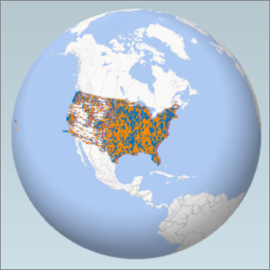

With Power Map, you can plot geographic and temporal data on a 3-D globe or custom map, show it over time, and create visual tours you can share with other people. You’ll want to use Power Map to:

* **Map data** Plot more than a million rows of data visually on Bing maps in 3-D format from an Excel table or Data Model in Excel.
* **Discover insights** Gain new understandings by viewing your data in geographic space and seeing time-stamped data change over time.
* **Share stories** Capture screenshots and build cinematic, guided video tours you can share broadly, engaging audiences like never before. Or export tours to video and share them that way as well.

You’ll find the **Map** button in the **Tours** group on the **Insert** tab of the Excel ribbon, as shown in this picture.

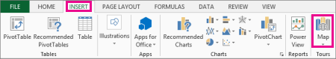

**Notes:**

* If you can’t find this button in your version of Excel, go to I don't see the Power Map button in Excel.
* If you have a subscription for Microsoft 365 Apps for enterprise, you have access to Power Map for Excel as part of the self-service business intelligence tools. Whenever any new Power Map features and performance enhancements are released, you'll get them as part of your subscription plan.  
  To learn about the Microsoft 365 subscription plans, see Explore Microsoft 365 ProPlus and Compare All Microsoft 365 for Business Plans.
* If you previously installed a preview version of Power Map, you’ll temporarily have two **Map** buttons on the **Insert** tab: one in the **Tours** group and one in the **Power Map** group. Clicking the **Map** button in the **Tours** group enables the current version of Power Map and uninstalls any preview versions.

1. How powerBi eliminated the need to host SharePoint Server on premises?

Answer:

Power BI, as a cloud-based business intelligence platform developed by Microsoft, offers several features and capabilities that reduce the need for hosting SharePoint Server on premises for certain data visualization and reporting needs. Here are ways in which Power BI eliminates the need to host SharePoint Server on premises:

* Cloud-Based Solution: Power BI is a cloud-based platform, which means that data and reports are stored and managed in the cloud. This eliminates the need for organizations to set up and maintain their own on-premises servers, such as SharePoint Server, to host and manage reports and dashboards.
* Scalability: Power BI is designed for scalability, allowing organizations to easily accommodate growing data and user needs without the complexities of managing on-premises infrastructure.
* Faster Deployment: Setting up and configuring an on-premises SharePoint Server can be time-consuming. Power BI's cloud-based nature enables faster deployment and setup, allowing users to start creating and sharing reports more quickly.
* Reduced Maintenance: On-premises servers like SharePoint Server require ongoing maintenance, updates, and patches. With Power BI, Microsoft handles infrastructure maintenance, ensuring that the platform is up-to-date and secure.
* Easy Sharing and Collaboration: Power BI Service, the cloud component of Power BI, allows for easy sharing and collaboration on reports and dashboards. Users can securely share reports with colleagues, customers, or stakeholders without the need for complex SharePoint setup.
* Automatic Data Refresh: Power BI supports automatic data refresh from various data sources, ensuring that reports always show the latest data. This process is managed in the cloud without the need for on-premises server resources.
* Cross-Device Accessibility: Power BI's web-based service and mobile apps allow users to access reports and dashboards from any device, promoting mobility and flexibility in accessing data insights.
* Integration with Existing Tools: While Power BI reduces the need for on-premises SharePoint Server, it can still integrate with SharePoint Online for document storage, collaboration, and access control, enhancing the overall user experience.
* Hybrid Options: For organizations that require a mix of on-premises and cloud solutions, Power BI offers hybrid capabilities that allow you to connect on-premises data sources while still leveraging cloud-based features.

It's important to note that while Power BI offers advantages in terms of cloud-based deployment, sharing, and scalability, there may be specific use cases where SharePoint Server remains relevant, especially if an organization requires more extensive content management, custom workflows, or integration with other enterprise systems. The decision to use Power BI or SharePoint Server depends on the specific needs and requirements of the organization.

1. Explain the updates done in Power Bi Service(power BI 2.0) as compared to older version ?

**We have updates on Features in Reporting, Modeling, Data Connectivity, Service, Mobile, Developers, and Visualizations.**

**Contents**

* [**Reporting**](https://powerbi.microsoft.com/en-us/blog/power-bi-july-2023-feature-summary/#post-24176-_Toc1705833432)
  + [**Smoothed and Leader lines – Updates**](https://powerbi.microsoft.com/en-us/blog/power-bi-july-2023-feature-summary/#smoothed-and-leader-liners)
  + [**On-Object Interaction – Updates**](https://powerbi.microsoft.com/en-us/blog/power-bi-july-2023-feature-summary/#post-24176-_Toc1573847150) 
    - [**Customize the Pane Switcher**](https://powerbi.microsoft.com/en-us/blog/power-bi-july-2023-feature-summary/#post-24176-_Toc1348209716)
    - [**CTRL click to open multiple panes in the Pane Switcher**](https://powerbi.microsoft.com/en-us/blog/power-bi-july-2023-feature-summary/#post-24176-_Toc289015742)
    - [**Treemap sub-selections now supported**](https://powerbi.microsoft.com/en-us/blog/power-bi-july-2023-feature-summary/#post-24176-_Toc1231899549)
    - [**Noteworthy bug fixes**](https://powerbi.microsoft.com/en-us/blog/power-bi-july-2023-feature-summary/#post-24176-_Toc309107500)
* [**Modeling**](https://powerbi.microsoft.com/en-us/blog/power-bi-july-2023-feature-summary/#post-24176-_Toc1110875475) 
  + [**Edit your data model in the Power BI Service– Updates (Preview)**](https://powerbi.microsoft.com/en-us/blog/power-bi-july-2023-feature-summary/#post-24176-_Toc2087254483)
  + [**Relationship validation**](https://powerbi.microsoft.com/en-us/blog/power-bi-july-2023-feature-summary/#post-24176-_Toc373590927)
* [**Data Connectivity**](https://powerbi.microsoft.com/en-us/blog/power-bi-july-2023-feature-summary/#post-24176-_Toc1095178652) 
  + [**Snowflake (Connector Update)**](https://powerbi.microsoft.com/en-us/blog/power-bi-july-2023-feature-summary/#snowflake-connector)
  + [**Google Analytics (Connector Update)**](https://powerbi.microsoft.com/en-us/blog/power-bi-july-2023-feature-summary/#post-24176-_Toc1886634515)
  + [**Azure Databricks, Databricks (Connector Update)**](https://powerbi.microsoft.com/en-us/blog/power-bi-july-2023-feature-summary/#post-24176-_Toc935919136)
  + [**Denodo (Connector Update)**](https://powerbi.microsoft.com/en-us/blog/power-bi-july-2023-feature-summary/#post-24176-_Toc1711227751)
  + [**EQuIS (Connector Update)**](https://powerbi.microsoft.com/en-us/blog/power-bi-july-2023-feature-summary/#post-24176-_Toc15101797)
  + [**Anaplan (Connector Update)**](https://powerbi.microsoft.com/en-us/blog/power-bi-july-2023-feature-summary/#post-24176-_Toc398368816)
* [**Service**](https://powerbi.microsoft.com/en-us/blog/power-bi-july-2023-feature-summary/#post-24176-_Toc2138467895) 
  + [**Dataset details page revamp**](https://powerbi.microsoft.com/en-us/blog/power-bi-july-2023-feature-summary/#post-24176-_Toc1675616134)
* [**Mobile**](https://powerbi.microsoft.com/en-us/blog/power-bi-july-2023-feature-summary/#post-24176-_Toc1006689221)
  + [**Datasets are coming to Power BI Mobile apps!**](https://powerbi.microsoft.com/en-us/blog/power-bi-july-2023-feature-summary/#post-24176-_Toc633844403)
* [**Developers**](https://powerbi.microsoft.com/en-us/blog/power-bi-july-2023-feature-summary/#post-24176-_Toc73400004) 
  + [**Boost Your Custom Visuals Performance: Check out our Latest Article!**](https://powerbi.microsoft.com/en-us/blog/power-bi-july-2023-feature-summary/#post-24176-_Toc969044262)
* [**Visualizations**](https://powerbi.microsoft.com/en-us/blog/power-bi-july-2023-feature-summary/#post-24176-_Toc1345279724) 
  + [**New visuals in AppSource**](https://powerbi.microsoft.com/en-us/blog/power-bi-july-2023-feature-summary/#post-24176-_Toc772577457)
  + [**Elevate Your Map Charts With Drill Down Map PRO**](https://powerbi.microsoft.com/en-us/blog/power-bi-july-2023-feature-summary/#post-24176-_Toc1560094775)
  + [**We are ready to present our new visual: an “all-in-one” Multi Target KPI card**](https://powerbi.microsoft.com/en-us/blog/power-bi-july-2023-feature-summary/#post-24176-_Toc168844247)
* [**Other**](https://powerbi.microsoft.com/en-us/blog/power-bi-july-2023-feature-summary/#post-24176-_Toc1980508642) 
  + [**WebView2 **](https://powerbi.microsoft.com/en-us/blog/power-bi-july-2023-feature-summary/#post-24176-_Toc277520133)

## **Smoothed and Leader lines – Updates**

**We are excited to announce the launch of one of our most highly acclaimed features! Report creators can now create smoother line and area charts, providing a more polished look to their visualizations. To access this setting, go to Lines > Shape > Line Type.**

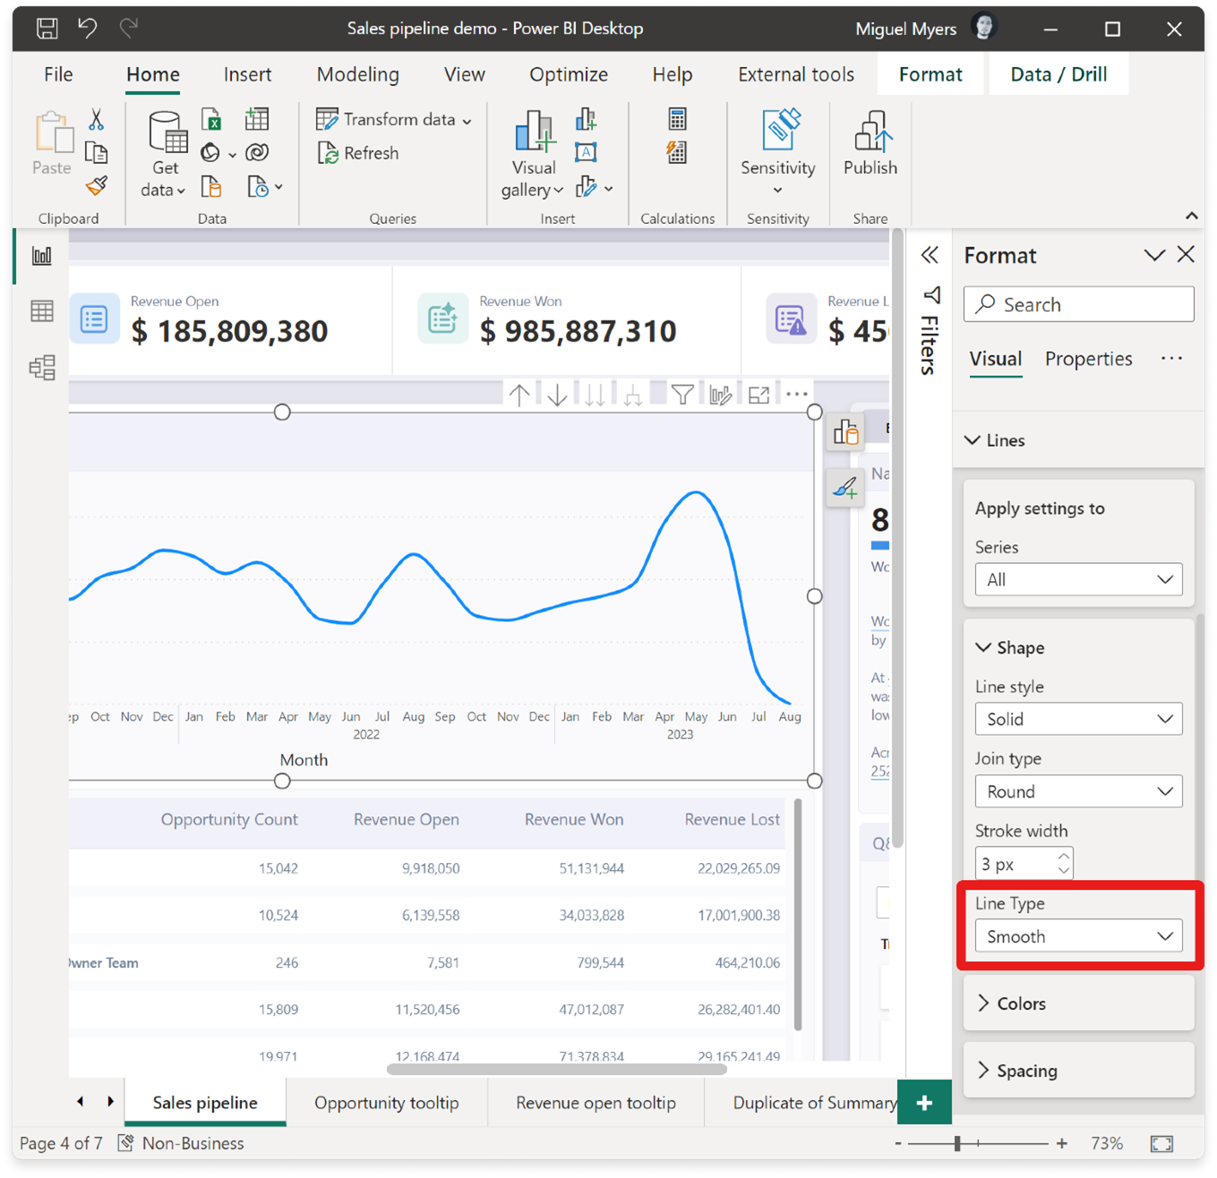

**We’ve recently added leader lines for both line and area charts. This new feature creates a visual connection between each data point and its corresponding label. To access this feature, simply navigate to the Data labels > Options > Leader lines.**

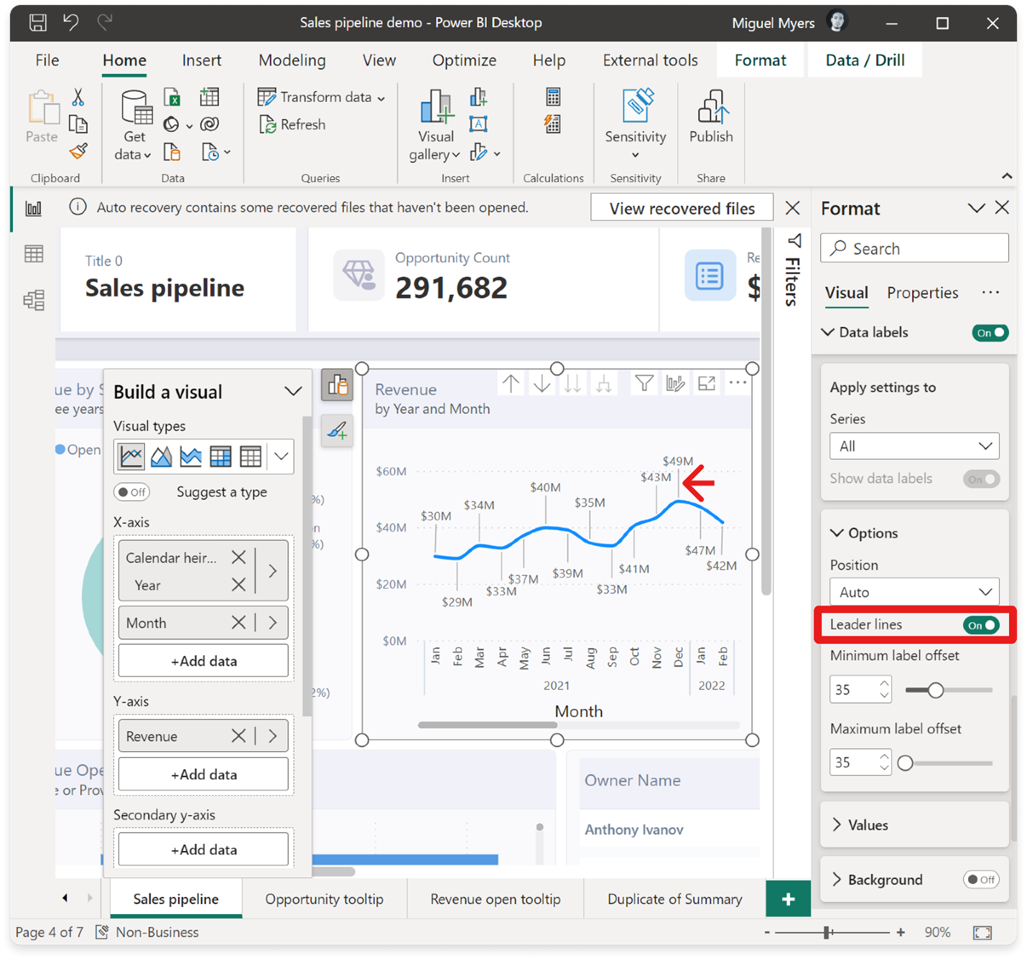

**These features are just the beginning of the many improvements we have in store for graphs, charts, plots, and markers in the coming months. Get ready for even more exciting updates!**

## **On-Object Interaction (Preview) – Updates**

**The new on-object interaction feature released to preview back in March. This month we bring more improvements and bug fixes.**

### **Customize the Pane Switcher**

**We’ve now added a new “+” button on the pane switcher to quickly add new panes directly from the pane switcher without having to go to the View ribbon. This menu also gives a brief description of what panes are available and what their functions are. Even better, the panes added to the switcher are saved across reports. Configure once and you’re done!**

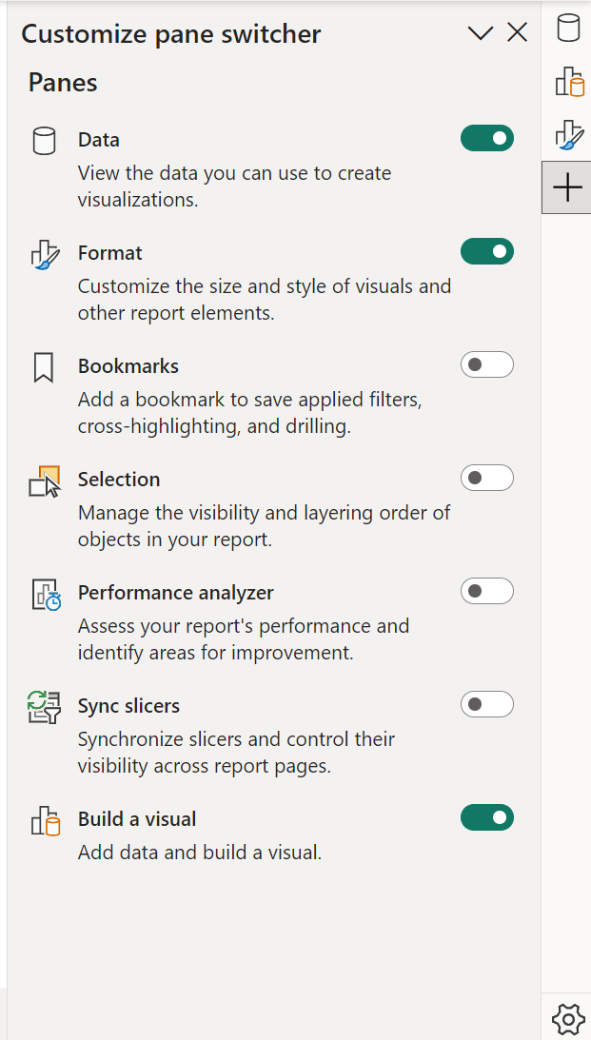

**You can also access the 2 preference settings released last month for “always show the pane switcher” and re-attaching the build menu as a pane by using the gear icon.**

### **CTRL click to open multiple panes in the Pane Switcher**

**In addition to the right click option “open in new pane”, it is now even easier to open multiple panes from the pane switcher by simply holding down the CTRL key and clicking the pane you wish to open.**

### **Treemap sub-selections now supported:**

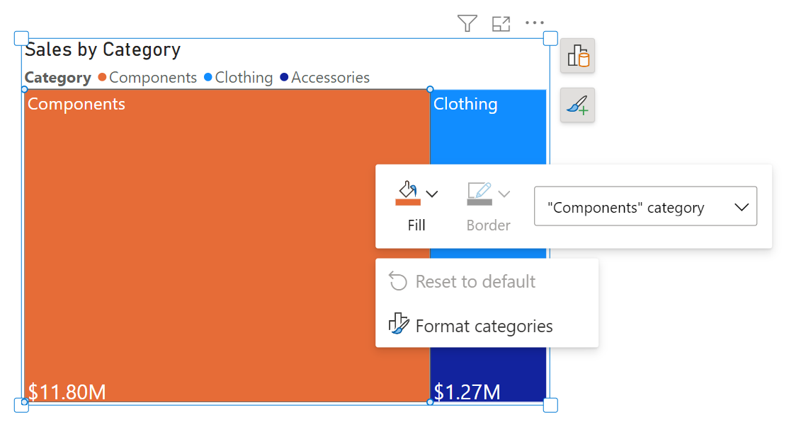

### **Noteworthy bug fixes:**

* **Overlap of the on-object buttons on the formula bar has finally been resolved! We appreciate your patience as this bug was a bit trickier to fix the right way.**
* **Visual tooltip showing automatically when opening the build menu, blocking the formatting on-object button is now fixed.**
* **Selected visual type is now reflected in the ribbon visual gallery accordingly.**
* **Mini-toolbar’s fill color icon now reflects conditional formatting gradient as well.**

**Thanks for continuing to try out the new preview and provide feedback. We’re working hard to react to your suggestions and add the necessary changes to make on-object work for you. Please continue to provide your comments directly in this blog post or in our community forum via the “Share feedback” button next to the preview switch.**

# **Modeling**

## **Edit your data model in the Power BI Service– Updates (Preview)**

**Data model editing in the Service feature released will preview in April. We’ve been busy reacting to your feedback and enhancing the experience. Below are the improvements we are adding this month:**

### **Relationship validation**

**We are adding relationship validation in the Service, making it easier to create and edit relationships in the web! Like Power BI Desktop, as you define the properties of your relationship, the system will automatically validate it and offer appropriate choices for cardinality and cross filter selections.**

**Please continue to submit your feedback directly in the comments of this blog post or in our** [**feedback forum**](https://go.microsoft.com/fwlink/?linkid=2231605)**.**

# **Data Connectivity**

## **Snowflake (Connector Update)**

**The Snowflake connector has been updated to include various performance improvements, such as usage of SQLBindCol. Users should experience better performance when running queries.**

## **Google Analytics (Connector Update)**

**The Google Analytics connector has been updated to support Google Analytics Data API (Google Analytics 4). To use this new functionality, use “Implementation 2.0” when connecting. Existing connections will not be affected.**

## **Azure Databricks, Databricks (Connector Update)**

**The Azure Databricks and Databricks connectors have been updated. Please find notes from the Databricks team below.**

* **Add a new DSRHandler to databricks-multicloud**
* **Fix UC_NOT_ENABLED and Catalog ‘spark’ not found error in legacy code path using Databricks.Contents**

## **Denodo (Connector Update)**

**The Denodo connector has been updated. Please find notes from the Denodo team below.**

* **This new version adds graphical support for the specification of native SQL queries at data source creation time.**

## **EQuIS (Connector Update)**

**The EQuIS connector has been updated. Please find notes from the EQuIS team below.**

* **Remove “Beta” attribute**
* **Retrieve report content as .csv to remove the row limitation of .xlsx files**
* **Optimize handling of facility groups in navigation tree**
* **Show report and/or location folders in navigation tree even if one or the other is empty**

## **Anaplan (Connector Update)**

**The Anaplan connector has been updated. Please find notes from the Anaplan team below.**

* **This version of Power BI connector for Anaplan includes backend changes for compatibility with ongoing Anaplan infrastructure updates. There is no change to user facing connector features.**

# **Service**

## **Dataset details page revamp**

**We are happy to announce the revamp of our dataset details page! Now, when you click on a dataset item in the OneLake data hub and workspace view, you will be directed to the redesigned page that not only enhances the look and feel but also introduces new capabilities for an improved user experience.**

**Here’s what you can expect to find on the dataset details page:**

* **Actions: You will find various actions that can be performed on the dataset, such as creating a report and refreshing the dataset. With this release, we have added the option to view the refresh history under the refresh menu.**
* **Dataset Metadata: Gain insights into the dataset through its description and last refresh time.**
* **Related Items: Explore existing related items associated with the dataset.**
* **Dataset Schema: Get a comprehensive view of the dataset’s tables and columns. Clicking on a table provides a table preview, with export capabilities available using paginated reports behind the scenes.**

**Additionally, we have made significant improvements to the related items list. It now showcases all the downstream and upstream dependencies for the dataset. This enhancement allows you to easily identify the sources of the dataset, composite model relations, reports, and dashboards associated with it.**

**We believe that these updates will greatly enhance your experience with the dataset details page, providing you with a more intuitive and comprehensive understanding of your data. We look forward to your feedback as you explore these new features!”**

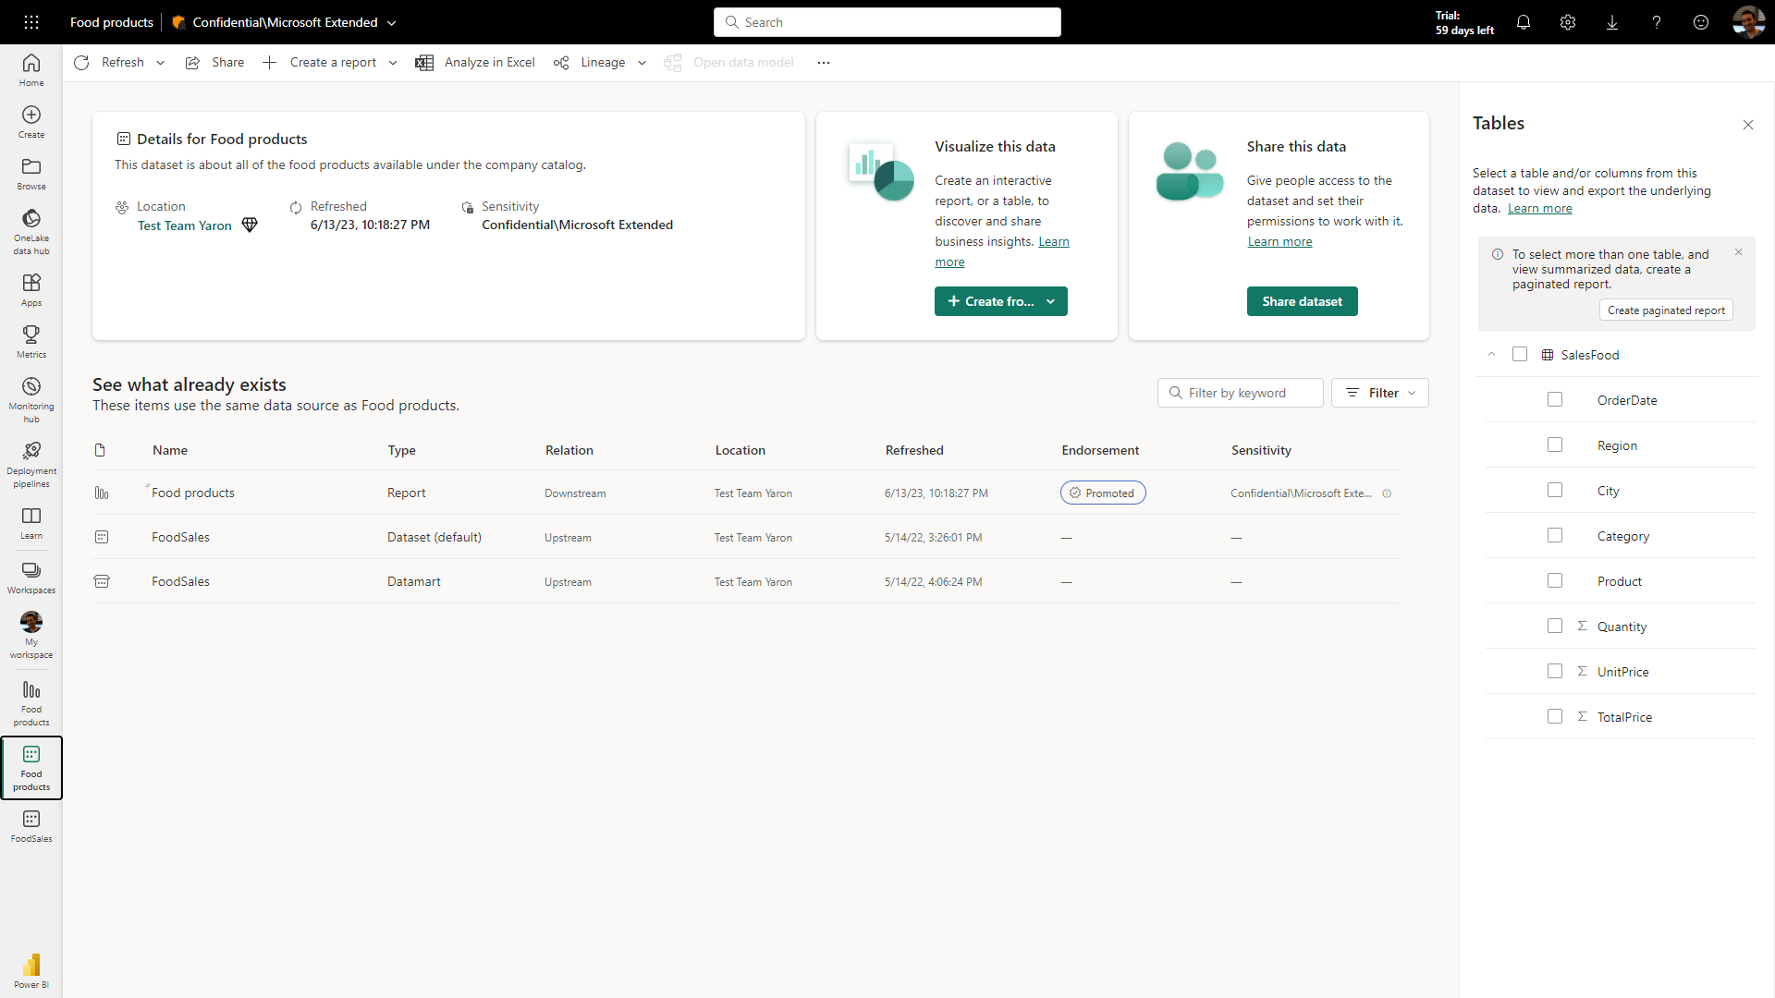

# **Mobile**

## **Datasets are coming to Power BI Mobile apps!**

**In the next Power BI Mobile app release, we are adding a long-waited feature that will help dataset owners and report creators to manage their dataset directly from their phone.**

**That means that you will be able to see in your mobile device datasets. Go to a workspace, make sure to select the “dataset” pill at the top and get the list of datasets, that you have access to in that workspace.**

**When tapping on a dataset, you will get the dataset metadata pane, which includes the name, owner, sensitivity label and also the latest refresh status. From this pane you can also trigger a dataset refresh – all directly from your mobile app!**

**Dataset owners will also get push notifications when schedule refresh fails. They will be able to view the failure details and be able to re-try the refresh while they are on-the-go.**

